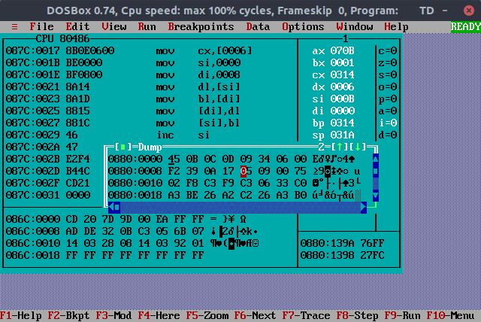8 Bit Block Exchange Without Using String Instruction

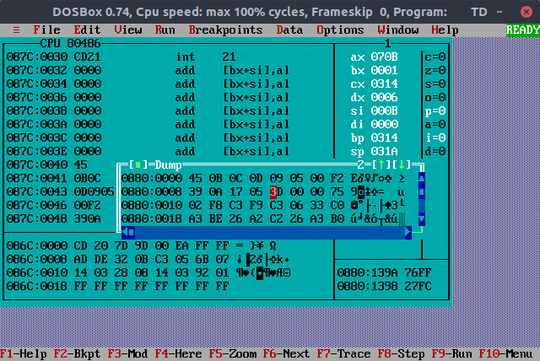

8 Bit Block Exchange Using String Instruction